Computer Language Coding Concepts

Command Calls in a Command Reference in a Diagram
Command calls in a command reference have been conceptually explained in the article Command Calls in a Command Reference.

This article only illustrates how command calls in a command reference look in a diagram.

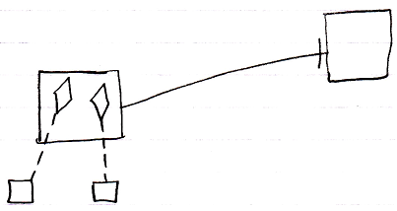

The square on the left is a command reference, because it points out its target definition, the square on the right, with a solid line, an object line. The command reference contains two command calls, displayed as diamonds. Those diamonds are calls, because they point out their definitions, the smaller squares at the bottom, with class lines, dashed lines. The square on the right could also have displayed the same calls, because both larger squares represent the same command object, that have the same contents.

The command reference and its target could also be replaced with a diamond arbitrarily, which make the command reference or target command executable.

The creation behavior of command calls in a command reference will not be further explained with diagrams in this article. Refer to the article Creation Behavior of Sub-Commands in a Diagram for an illustration of how the creation behavior of sub-command looks in a diagram.

See also: Command Calls in a Command Reference,
Creation Behavior of Sub-Command in a Diagram

Author & Copyright: Jan-Joost van Zon Date: August 9, 2008 – August 12, 2008 Location: Oosterhout, The Netherlands Status: Finished

